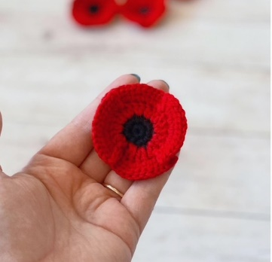
Stratford Poppy Project
The Town of Stratford is looking for poppies made with a bright poppy red, worsted weight, ACRYLIC ONLY, size 4 yarn. Our Top Yarn choice is: Soft Classic, Solid Yarn by Loops and Threads in Bright Red (found at Michaels). Other red, acrylic yarns such as Bernat Super Value in Berry, or Red Heart Super Saver in Cherry Red, are also great options to make your poppy! For the poppy, you will need approximately 17-20 yards of red yarn and 2-3 yards of black yarn. You will also need US 9 knitting needles or a size 5mm/J crochet hook. Needle or hook size may be adjusted but finished poppy should be between 4-5 inches in diameter.
*Red zip ties will be used to tie poppies onto the Poppy Drape. No tails please. Please fasten off.

Crochet Pattern
Abbreviations
Ch: chain(s) | Dc: double crochet | Sc = single crochet | Sl st = slip stitch | (12) = indicates number of stitches at end of round
Pattern designed by Hania Wojtowicz
With black, make a slip knot and ch 2.
Round 1: 12 dc in second ch from hook. Join with sl st to first dc. Fasten off.
Round 2: Using red yarn, join into the top of any of the black dc. Ch 3 (counts as a dc). 1 dc into the same stitch. 2 dc into each of the remaining dc. Join with sl st to top of ch 3. (24)
Round 3: Ch 1. 2 dc into each of the next 4 dc, sc into next dc. *sc in next dc, 2 dc into each of the next 4 dc, sc in next dc*. Repeat from * to * 2 more times. Join with sl st into bottom of starting ch 1. (40)
Round 4: *2 dc into each of the next 8 dc, slip stitch between the 2 sc of the previous row*. Repeat from * to * three times. Fasten off.
Follow along to the video tutorial by Mikey of The Crochet Crowd: Easy Crochet Poppy Pattern with The Crochet Crowd | Beginner Tutorial

Knit Pattern
Abbreviations
K: knit | P: purl | K2tog: knit 2 together | (Sl1, K2tog, psso): Slip 1 purl-wise, knit 2 together, pass slip stitch over
Pattern designed by Susan Simms
With red, cast on 52 sts and fasten off.
Work the next 8 rows as follows:
Right side: *K10, p3* repeat from * to * to end.
Wrong side: *K3, P10* repeat from * to * to end.
Cut red and fasten off.
Change to black tying to red at needle and fasten off.
Next row: K2 tog across
Next row: P across
Next row: *(Sl1, K2tog, psso)* repeat from * to* across to last 2 sts. K2 tog.
Cut yarn about 10" long and thread through the last stitches with a darning needle. Pull tight while removing from needle. Sew sides up with black, then with red using the mattress stitch. There should be no seam showing.
Fasten off all tails.
Follow along to the video tutorial by Marly Bird: Easy Knit Poppy Pattern with Marly Bird | Beginner Tutorial



